**2021 past paper**

1.

**AREA arithmetic,CODE,READONLY**

**MOV R1,#6**

**MOV R2,#2**

**ADD R0,R1,R2**

**SUB R3,R1,R2**

**MUL R4,R1,R2**

**LOOP**

**CMP R1,R2**

**BLT ENDLOOP**

**SUB R6,R1,R2**

**ADD R5,#1**

**MOV R1,R6**

**B LOOP**

**ENDLOOP**

**HERE B HERE**

**END**

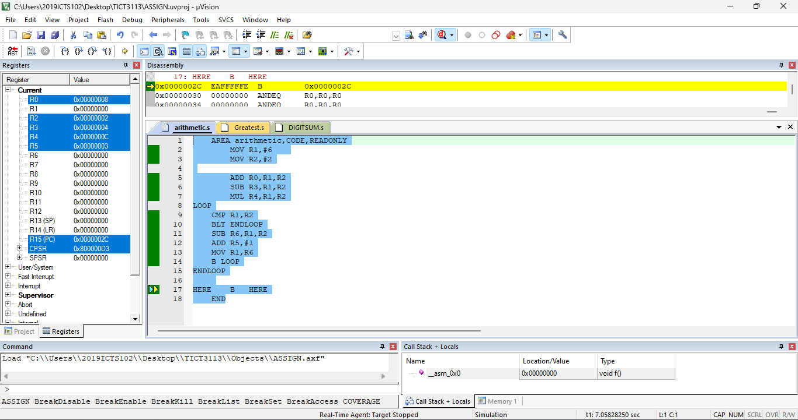

2. **AREA PalindromeCheck, CODE, READONLY**

**ENTRY**

**LDR R1, =input_string**

**BL clean_string**

**BL check_palindrome**

**MOV R7, #1**

**SWI 0**

**clean_string**

**LDR R2, =cleaned_string**

**MOV R3, #0**

**clean_loop**

**LDRB R4, [R1, R3]**

**CMP R4, #0**

**BEQ done_cleaning**

**CMP R4, #'A'**

**BLT ignore_char**

**CMP R4, #'Z'**

**BLE to_lower**

**CMP R4, #'a'**

**BLT ignore_char**

**CMP R4, #'z'**

**BGT ignore_char**

**store_char**

**STRB R4, [R2], #1**

**B next_char**

**ignore_char**

**B next_char**

**to_lower**

**ADD R4, R4, #32**

**B store_char**

**next_char**

**ADD R3, R3, #1**

**B clean_loop**

**done_cleaning**

**MOV R4, #0**

**STRB R4, [R2]**

**MOV PC, LR**

**check_palindrome**

**LDR R2, =cleaned_string**

**LDR R3, =cleaned_string_end**

**MOV R4, R2**

**find_end**

**LDRB R5, [R4], #1**

**CMP R5, #0**

**BEQ set_end**

**B find_end**

**set_end**

**SUB R3, R4, #2**

**palindrome_loop**

**LDRB R5, [R2], #1**

**LDRB R6, [R3], #-1**

**CMP R5, R6**

**BNE not_palindrome**

**CMP R2, R3**

**BGE palindrome_done**

**B palindrome_loop**

**not_palindrome**

**MOV R0, #2**

**MOV PC, LR**

**palindrome_done**

**MOV R0, #1**

**MOV PC, LR**

**input_string**

**DCB "Madam, I’m Adam", 0**

**cleaned_string**

**SPACE 64**

**cleaned_string_end**

**END**

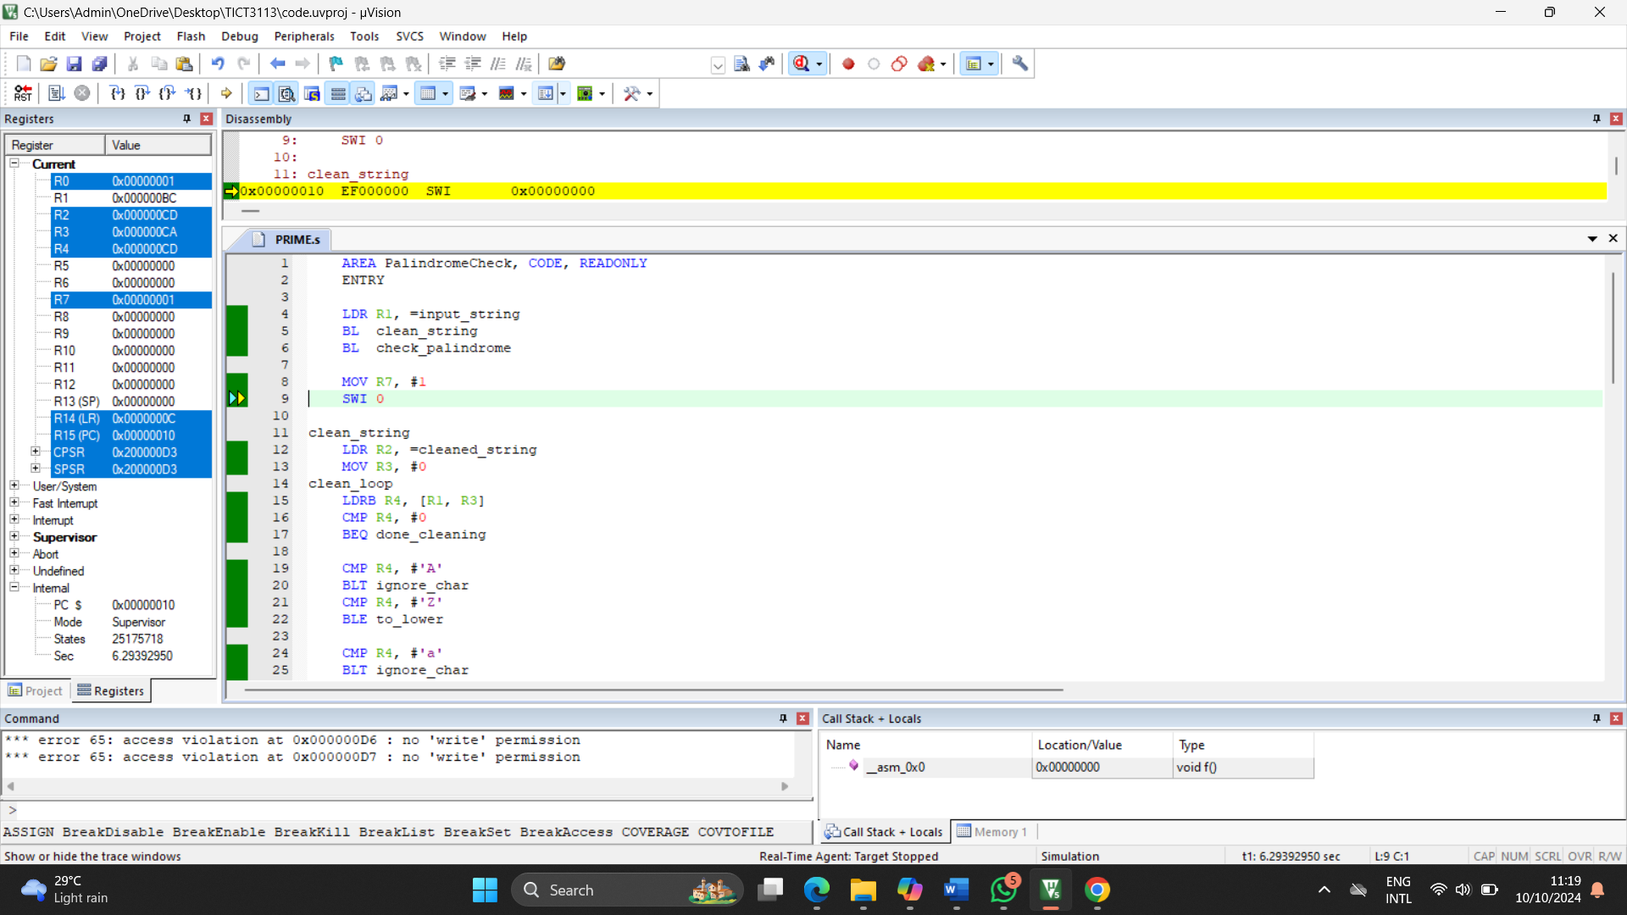

3.

**AREA digit_sum,CODE,READONLY**

**MOV R1,#1**

**MOV R2,#7**

**MOV R0,#0**

**LOOP**

**CMP R1,R2**

**BGT ENDLOOP**

**ADD R3,R1**

**ADD R1,#1**

**B LOOP**

**ENDLOOP**

**MOV R1,R3**

**HERE B HERE**

**END**

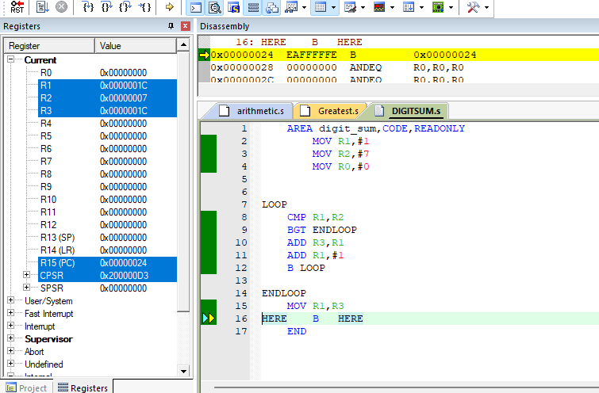

**2020 past paper**

1. **AREA javacode, CODE, READONLY**

**LDR R0, =label**

**MOV R1, #0**

**MainLoop**

**LDRB R2, [R0], #1**

**CMP R2, #0**

**BEQ EndCheck**

**CMP R2, #'('**

**BEQ IncrementOpen**

**CMP R2, #')'**

**BEQ DecrementClose**

**B MainLoop**

**IncrementOpen**

**ADD R1, R1, #1**

**B MainLoop**

**DecrementClose**

**SUB R1, R1, #1**

**B MainLoop**

**EndCheck**

**CMP R1, #0**

**MOVEQ R1, #1**

**MOVNE R1, #2**

**InfiniteLoop**

**B InfiniteLoop**

**label**

**DCB "public static void main(String arg[]){for(int i=0; i<5; i(){(}}", 0**

**END**

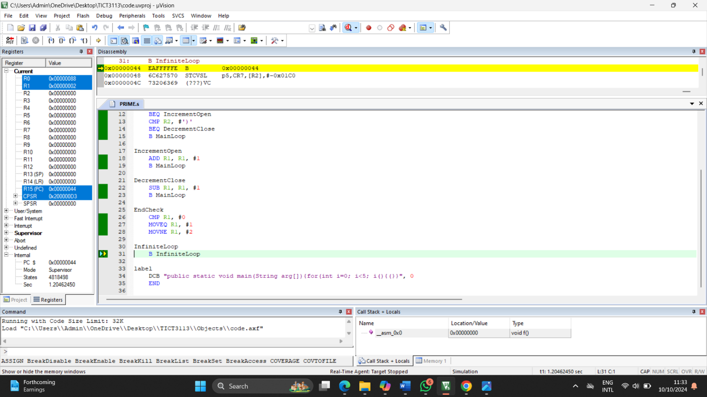

2.

**AREA mostOccurrence, CODE, READONLY**

**LDR R0, =number**

**MOV R1, #0**

**MOV R2, #0**

**MOV R3, #0**

**MOV R4, #0**

**MOV R6, #0**

**FindMostOccurring**

**LDRB R5, [R0, R6]**

**CMP R5, #0**

**BEQ Finish**

**MOV R2, #0**

**MOV R7, R6**

**CountOccurrences**

**LDRB R8, [R0, R7]**

**CMP R8, #0**

**BEQ CheckMax**

**CMP R8, R5**

**ADDNE R7, R7, #1**

**BNE CountOccurrences**

**ADD R2, R2, #1**

**ADD R7, R7, #1**

**B CountOccurrences**

**CheckMax**

**CMP R2, R1**

**BLE UpdateCounter**

**MOV R1, R2**

**MOV R4, R5**

**UpdateCounter**

**ADD R6, R6, #1**

**B FindMostOccurring**

**Finish**

**MOV R0, R4**

**HERE**

**B HERE**

**number DCB 4, 5, 9, 9, 7, 7, 8, 7, 0**

**END**

